University of Guelma / Department of Letters and English Language / 1st year Phonetics / Mrs. Boudra Amina

**lesson 2: PHONEMIC VS PHONETIC TRANSCRIPTION**

**Phonetic transcription** (also known as **phonetic script** or **phonetic notation**) is the visual representation of speech sounds (or [phones](https://en.wikipedia.org/wiki/Phone_(phonetics))) by means of [symbols](https://en.wikipedia.org/wiki/Symbols). The most common type of phonetic transcription uses a phonetic alphabet, such as the [International Phonetic Alphabet](https://en.wikipedia.org/wiki/International_Phonetic_Alphabet).

**There are two ways in which we can transcribe speech**

|  |  |
| --- | --- |
| ‘strewn’ | /strun/ |
| ‘tenth’ | /tenθ/ |
| ‘clean’ | /kli:n/ |

1. **Phonemic transcription**, also sometimes known as **‘broad’ transcription**, involves representing speech using just a unique symbol for each phoneme of the language. We might transcribe the following three words phonemically like this:

Here you can see that ‘strewn’ has 5 sounds and ‘tenth’ and ‘clean’ have 4 sounds, and every sound is represented uniquely.

**Note** that phonemic transcription is placed between **/ slashes /**.

* When we transcribe phonemically, we are representing not actual sounds, but abstract mental constructs. These are the categories of sound that speakers understand to be ‘sounds of their language’.

1. **Phonetic transcription**, also sometimes known as **‘narrow’ transcription**. This involves representing additional details about the contextual variations in pronunciation that occur in normal speech.  We might transcribe the same three words phonetically like this:

|  |  |
| --- | --- |
| ‘strewn’ | [stru:n] |
| ‘tenth’ | [tʰen̪θ] |
| ‘clean’ | [kl̥i:n] |

Here you can see that:

* ‘strewn’ has a long vowel, represented by the colon diacritic [:].
* ‘tenth’ has an aspirated initial [tʰ] shown by the superscript [ʰ];
* ‘clean’ has a long vowel, represented by the diacritic [:]; and a voiceless [l̥], represented by the small subscript circle diacritic, because the normal voiced quality of [l] is suppressed by the aspiration of the [k] before it.

**Note** that phonetic transcription is placed between **[square brackets]**.

* When we transcribe phonetically, we are representing not abstract mental constructs, but rather the actual sounds in terms of their acoustic and articulatory properties.

**For example** from these phonetic transcriptions you can see that the ‘t’ sounds are phonetically different  – the ‘t’ in ‘strewn’ is not aspirated, while the ‘t’ in ‘tenth’ is aspirated. Speakers of English hear both [tʰ] and [t] as instances of the phoneme /t/ and these are allophones of the phoneme /t/.

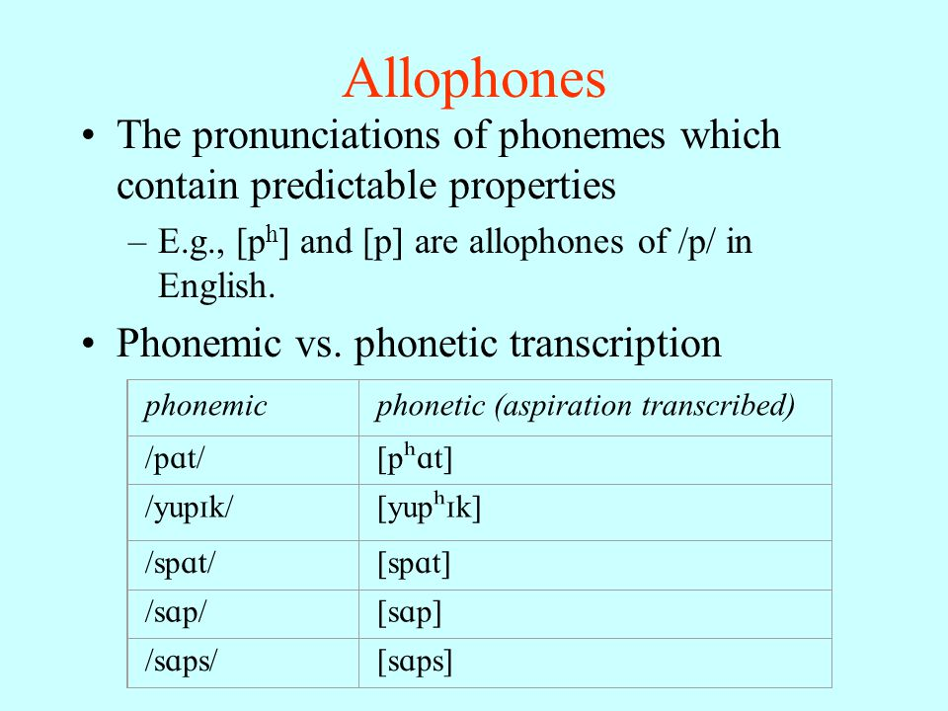

**Phonemic and phonetic transcription both have their purposes.**

* The goal of a phonemic transcription is to record the ‘phonemes as mental categories’ that a speaker uses, rather than the actual spoken variants of those phonemes that are produced in the context of a particular word. An English speaker has internalised a rule that says ‘sounds like /t/ are always aspirated when word-initial’, so they’ll automatically make the /t/ in ‘tenth’ aspirated.
* Phonetic transcription on the other hand specifies the finer details of how sounds are actually made. So phonemes are abstract mental categories in people’s minds, and these /categories/ are realised as [actual sounds] from people’s mouths. The spoken variants of each phoneme are known as its allophones. Now we can say things like: The phoneme /t/ has two allophones [t] and [tʰ].

