**Univeristy of Guelma 1st year Linguistics**

**Department of English Mrs. BOUDRA Amina**

**LESSON FIVE: INTRODUCTION TO SEMIOTICS**

Semiotics (from the Greek 'semeion') is the study of signs and texts, which is to say that it is the study of meanings, communication, and interpretation significance.

Semiology is the term used for the science of sign

It's the study of meaning-making and meaningful communication

Semiotics is related to linguistics, the study of language but, it limits itself to the signs and symbols part of communication

Semiotics which is the study of **visual language** and**signs** looks at how meaning is created, not just with words but also with images, symbols, gestures, sounds, and design.

We use semiotics to look at how different modes of communication (e.g. language, visuals, or gestures) work together to create **meaning in context.** This means that **where** and **when** we observe signs will impact their meaning. For example, a thumbs-up gesture usually means 'okay', but if seen at the side of the road, it means the person is looking for a free ride in a stranger's car!



Semiotics can help us develop a deeper understanding of the world around us, including the media we see (e.g. films, news, adverts, novels). It helps us to recognize the **whole intended meaning** of something.

**Signs in semiotics**

In semiotics we analyze **signs**, but what exactly are they?

In semiotics, the term sign can refer to anything that is used to **communicate meaning**. Anything that creates meaning or capable of representing something else is a sign. There is a wide variety of ways we as humans communicate meaning with each other, such as:

* **Words** (e.g. the word *breakfast* is used to describe the meal we eat in the morning)
* **Images** (e.g. the images used alongside a news article will impact the readers' understanding of that article)
* **Colors**(e.g. the red light on a traffic light means *stop*)
* **Symbols**(e.g. the exclamation mark '!' can convey a sense of surprise or excitement)
* **Gestures**(e.g. a 'thumbs up' shows positivity)
* **Sounds**(e.g. music played on the piano in the minor key can create a sense of sadness)
* **Fashion**(e.g. clothing can reveal a lot about a person's socioeconomic status)

The meaning of signs can differ depending on the **social situation**and the **cultural context**.

For example, whilst the 'thumbs up' gesture has positive connotations in many countries, it is considered offensive in Greece, Iran, Italy, and Iraq. Another example is the colour yellow.

In the Western world (e.g. the UK and the USA), yellow is often associated with springtime and warmth; however, in Latin America (e.g. Mexico, Brazil, and Colombia) yellow can symbolise death and mourning. As you can see, it's important to study signs in context!

## Semiotic theory

The Swiss linguist Ferdinand de Saussure (1857-1913) and the American philosopher Charles Sanders Peirce (1839–1914) are widely considered the founders of modern semiotics. In the early 1900s, Saussure introduced the concept of **signs**in semiotics. He suggested that each **sign (the basic unit of meaning)** is made of two parts; the **signifier** and the **signified**.

* **Signifier =**The word, image, sound, or gesture representing a concept or meaning.
* **Signified =**The interpretation of the meaning of the signifier.

These two parts of a sign are always connected and cannot be separated.

An example of a sign is the word 'dog'.

* **The signifier** is the word 'dog' itself.
* **The signified meaning**is the small furry mammal, often kept as a pet.

A further example is this hand gesture:

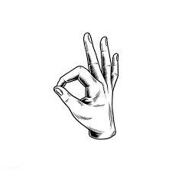

* **The signifier**is the symbol made by joining the thumb and the index finger together.
* **The signified meaning**(in the Western world)is 'everything's okay'.

### Types of signifiers

According to Charles Sanders Peirce, there are **three**different signifiers; **Icons, Indexes,**and **Symbols.**

#### Icon signifier

An icon is a signifier with an obvious connection and physical resemblance to the signified thing. Photographs, illustrations, and maps are good examples of icon signifiers.



This image is used to represent the United Kingdom. It is an icon signifier as it has an obvious and accurate resemblance to the physical shape of the United Kingdom.

#### Index signifier

Index signifiers are a little less obvious than icon signifiers. They are usually representations of the **relationship between the signified and the signifier.**The index signifier cannot exist without the presence of the signified. For example, smoke is an index signifier for fire. Most of us know the relationship between smoke and fire and know that there cannot be any smoke without a fire.

Example

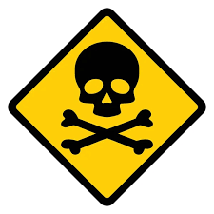[**SIGN UP NOW FOR FREE**](https://app.studysmarter.de/signup-website/?wpcn=schule_english_semiotics&pcn=schule_english_semiotics&lang=en&web_campaign=schule_english_semiotics&is_pupil=true&maintopic_id=9068124&summary_id=43396604&course_subject=7466614&&_forward_params=true&web_source=website&_smtype=3&domain=uk&conversion_element=lock-image-ctabGtrguxJ6qlES0LtWUXsp3)

Many of you will have seen this image placed on the back of potentially dangerous household products, such as bleach.

The image is not a literal representation of what can be found in the bottle (i.e. the bottle of bleach isn't full of bones!); instead, it represents the relationship between the product and the user (i.e. if someone were to drink the bleach, they could die).

The understanding of index signifiers can either be **natural** or **learned**. For example, most of us know from a very young age that a frown suggests a person is unhappy. On the other hand, we have to learn that the skull and crossbones (shown above) represent death.

#### Symbol signifier

Symbol signifiers are the most abstract of the three, as there is no apparent connection between the signifier and the signified. Symbol signifiers can differ from country to country, and we have to take time to teach and learn their meaning.

Examples of symbol signifiers include the alphabet, numbers, and punctuation.

For example, there is no physical or literal connection between the pound symbol (£) and money itself; however, it is a symbol that everyone in the UK will understand.

Icon and index signifiers can also become symbol signifiers over time. Sometimes the thing that the icon or index signifier represents changes or becomes outdated, but the signifier is so well-known that it remains.

Example

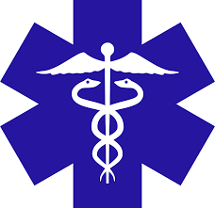**IGN UP** The image of the caduceus signifies medicine.

This is an image of the staff (stick) carried by the Greek god Hermes. The original image can be traced back to 4000 BC and is believed to have associated meanings with trade, liars, and thieves.

However, today we associate this symbol with medicine, and even though there is no obvious link between the image and medicine, this sign can be seen in pharmacies and hospitals all over the world.

### Types of signified meaning

Just like how there are three different types of signifiers, there are also three different types of signified meaning. They are: **denotative meaning, connotative meaning,**and **myths.**

#### Denotative meaning

A sign's denotative meaning is its **literal meaning.**These are the obvious meanings everyone knows, i.e., the meaning found in the dictionary. For example, the denotative meaning of the word 'blue' is a primary color between green and violet in the color spectrum'.

#### Connotative meaning

A sign's connotative meaning includes all of its implied and associated meanings. For example, the connotative meanings for the word 'blue' include feelings of sadness, representations of the sky and the ocean, and symbolism of trust, loyalty, and wisdom.

The interpretation of a sign's connotative meaning usually depends on the individual, and the understanding can differ from person to person.

#### Myths

A sign's mythological meaning is usually very old and has been passed down through many generations. Mythological meanings are often religious or cultural and include many things seen in our daily lives, such as norms, values, and manners.

An example is the yin and yang image, which has many mythological meanings in Chinese cultures, such as balance, femininity, darkness, and passivity.

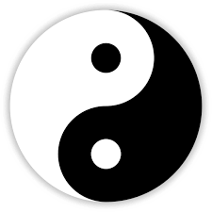

## Semiotic analysis

Although the process of semiotic analysis has undoubtedly been around for many years, modern-day semiotic analysis in linguistics was introduced by Ferdinand de Saussure and Charles Sanders Peirce in the early 1900s.

Semiotic analysis is when we take a medium of communication (e.g. a novel, a blog, a poster, a textbook, an advertisement etc.) and **interpret the denotative, connotative, and mythological meaning of all of the signs together in context.**

We can use semiotic analysis when conducting discourse analysis. For example, when analyzing a news article, it's important to not only consider the words used, but also how the words work alongside the images, colors, and advertisements also used. The combination of these different signs could potentially have a different meaning than viewing them on their own.

## Semiotics examples

One example of semiotics is the use of a red stop sign on a street. The sign itself is a symbol that represents the concept of "stop" and is universally recognized as such. The color red is also a signifier of danger or caution, which adds to the overall meaning of the sign. This is an example of how semiotics is used to convey meaning through the use of symbols and signifiers.

Let's take a look at another example of semiotic analysis.

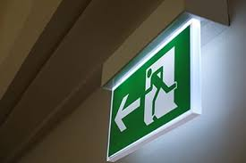

What do you think this sign means?

Although there are no words here, most people around the world will recognize this as an**emergency exit sign**. The combination of the color green (which has connotations with 'go'), the arrow pointing left (a universally recognized icon signifier), and the image (an index signifier which shows the relationship between going left and exiting through a door), creates the semiotic meaning of the sign.

Reference <https://www.studysmarter.co.uk/explanations/english/semiotics/>