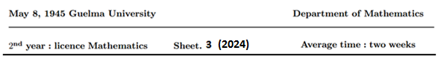

**Exercise 1. (Two variables)**

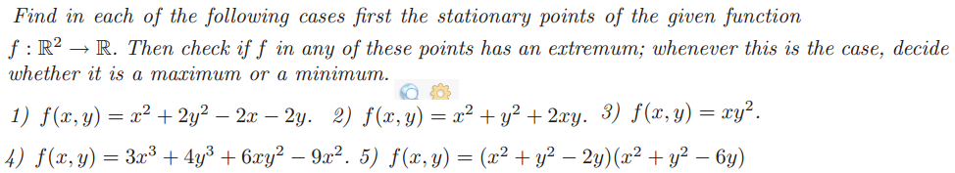

**Exercise 2. (Three variables)**

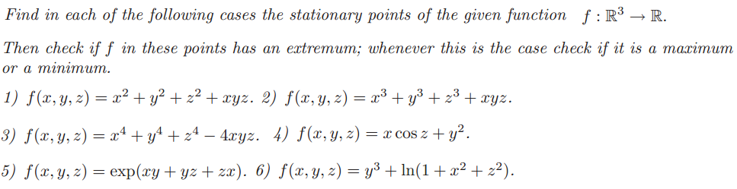

**Exercise 3.**

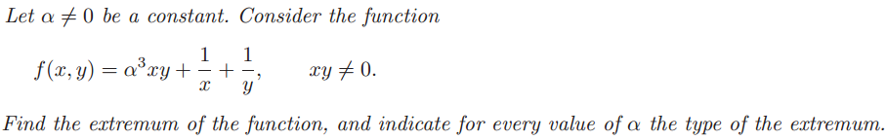

**Exercise 4.** 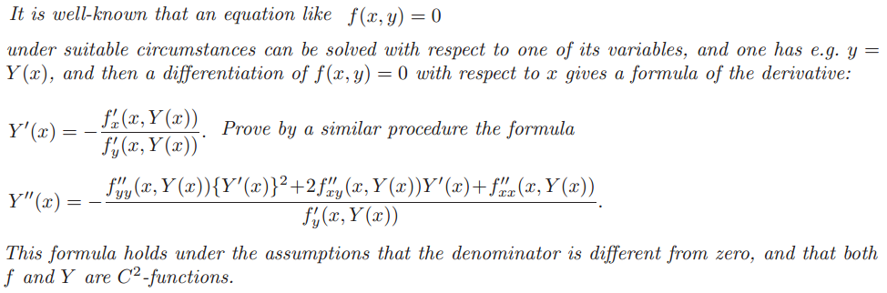

**Exercise 5.**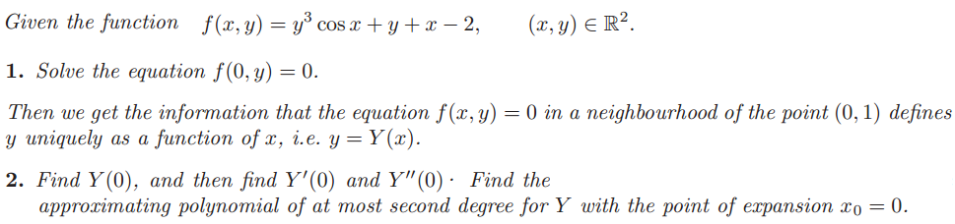

**Remark : Exercise 1.(Q3 and Q4)+ Exercise 2.(Q3 ,Q4 and Q6) are additional questions**

**Exercise 4 (additional)**

**Solution : Sheet 3**

**Exo1. (1)**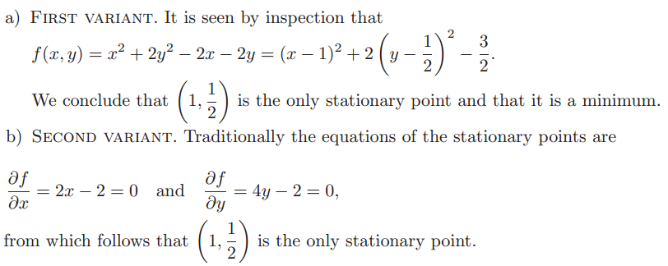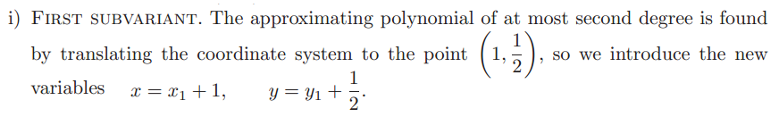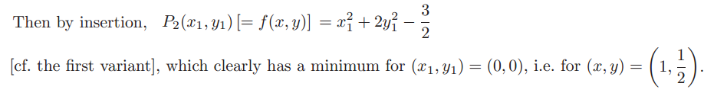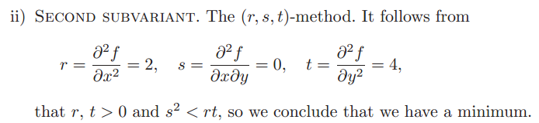

**(2)**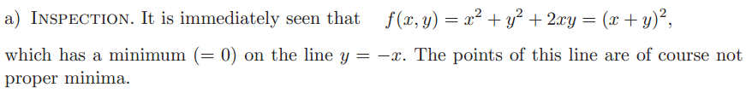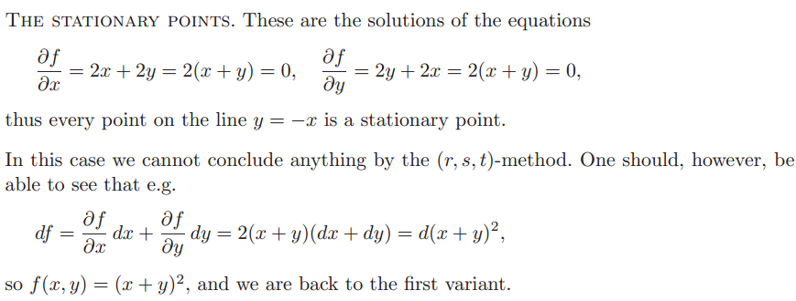

**(5)**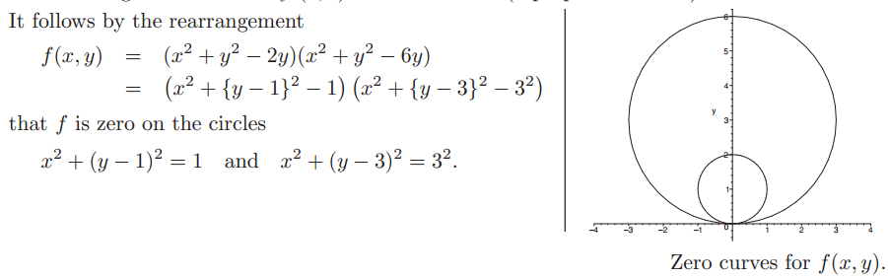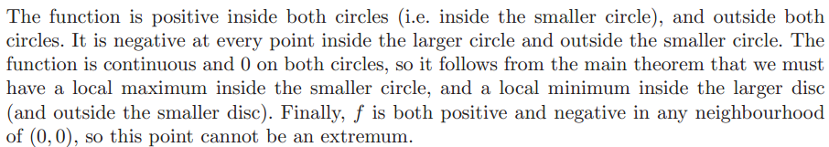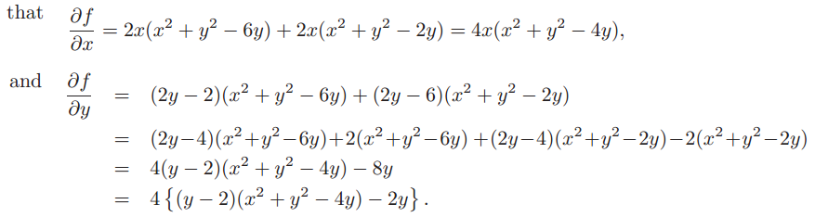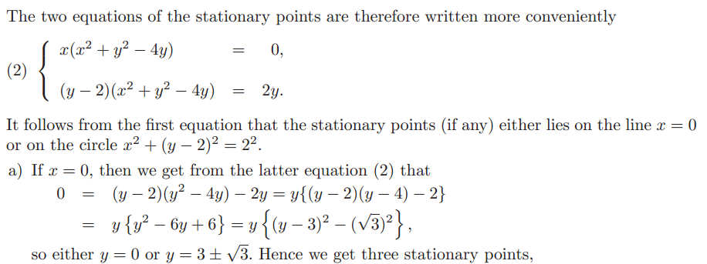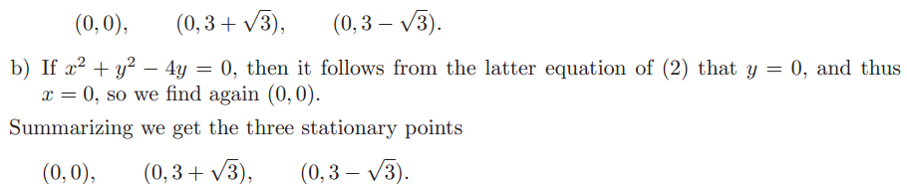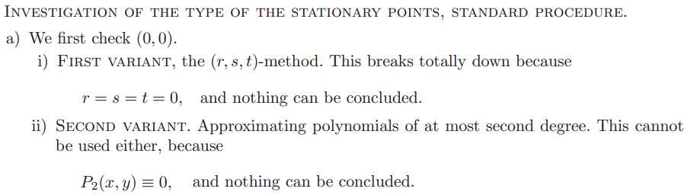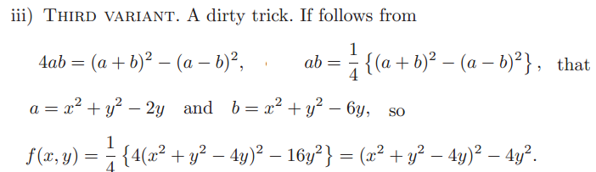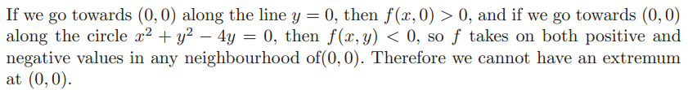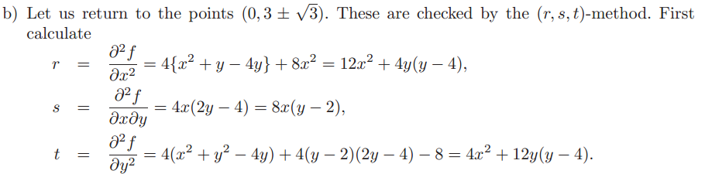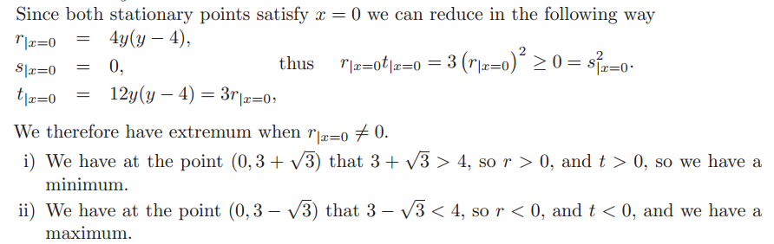

**Exo2. (1) 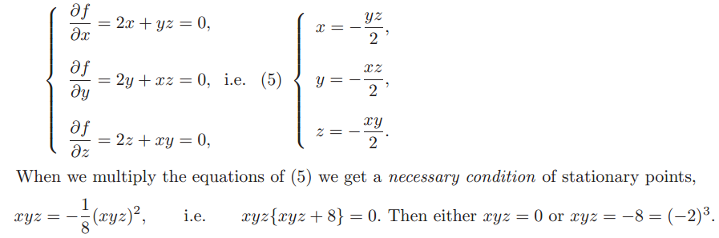**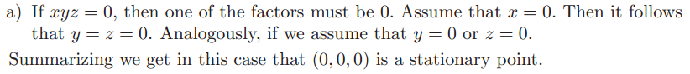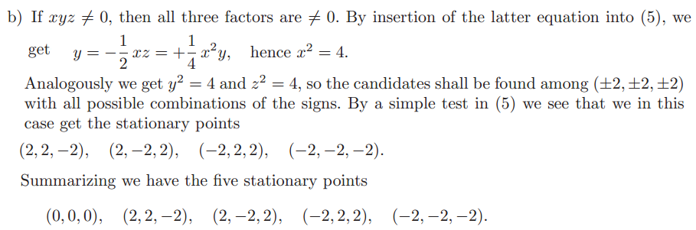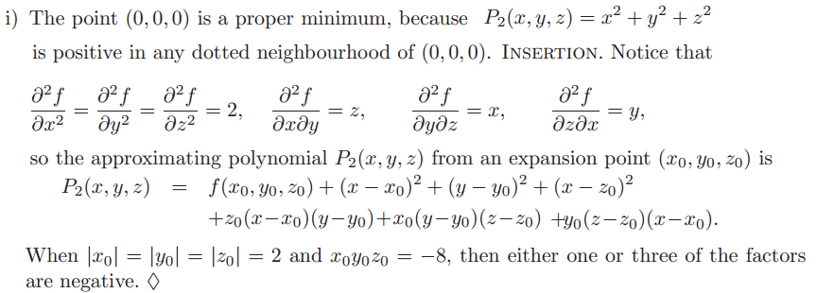

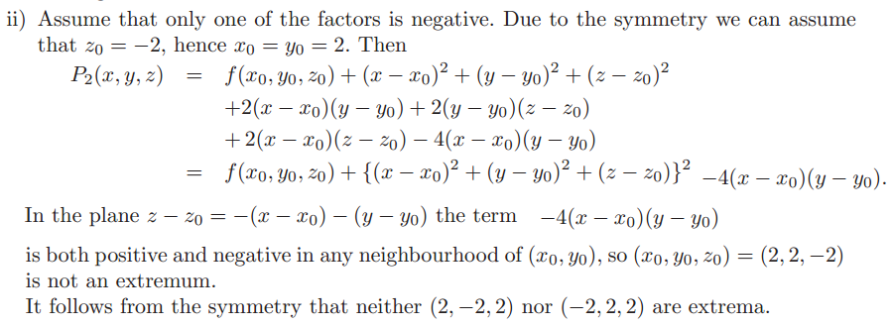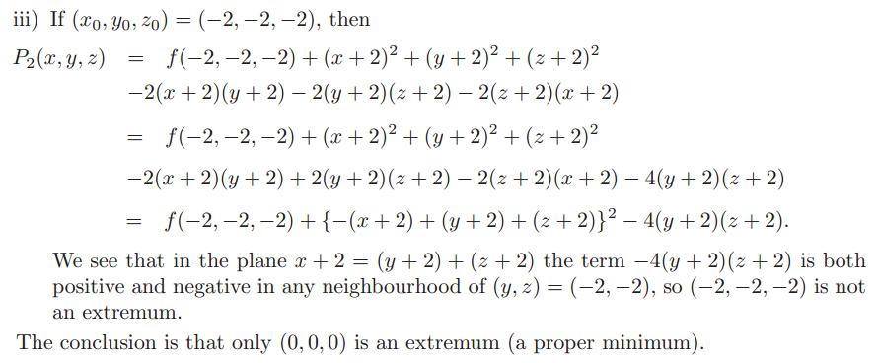

**(2)**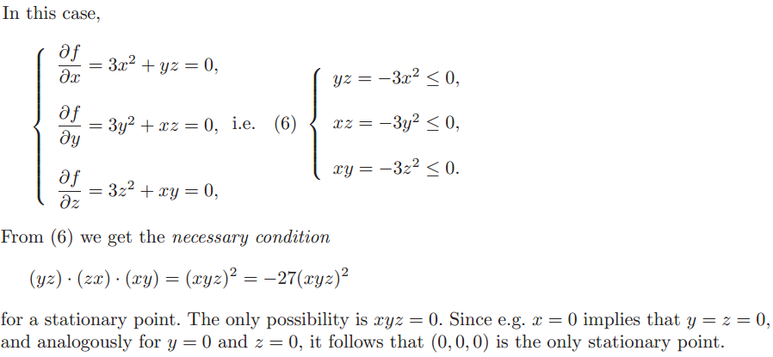

**(5)** 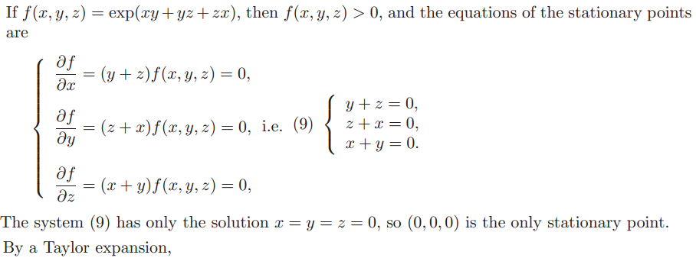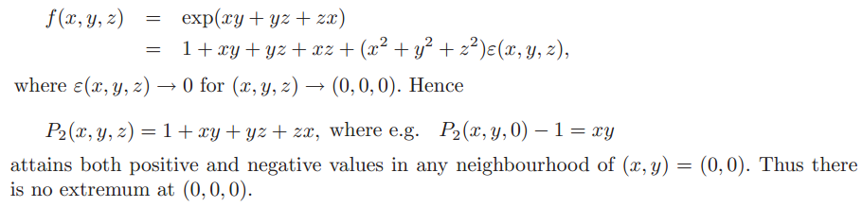

**Exo3**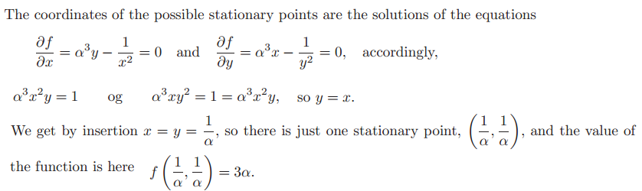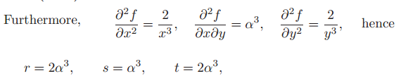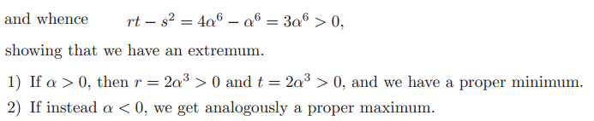

**Exercise 5.**