**Solution TD 0**

**Exercice 1.**  Calcul Direct

**Exercice 2. (A)** Draw and then examine whether $A$ is an open or closed set in the following cases: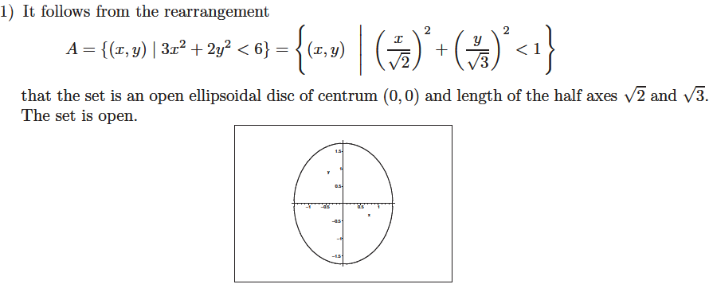

3) 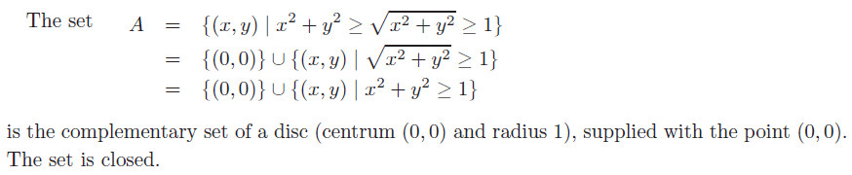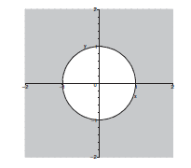

2) 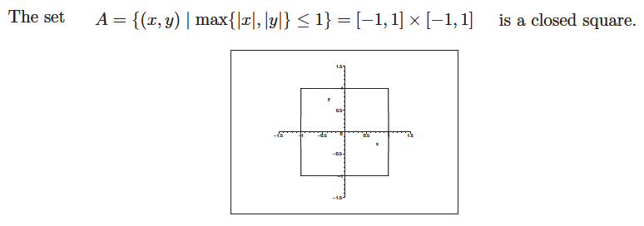

4) 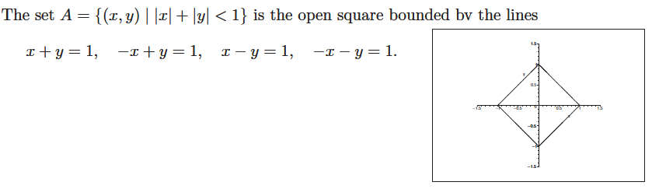

**B)** Find the Cartesian equation

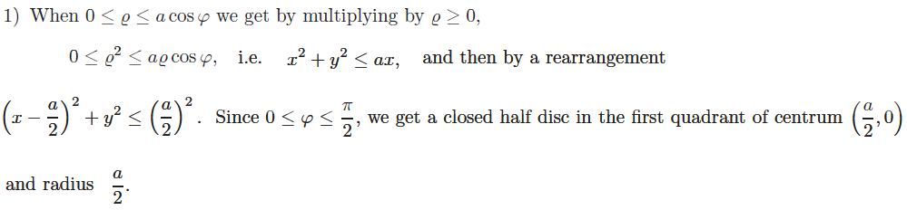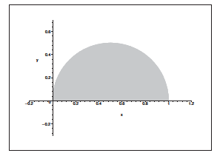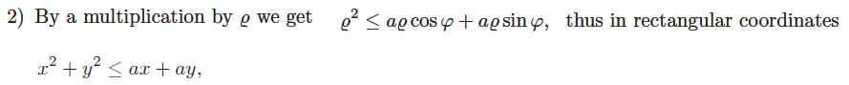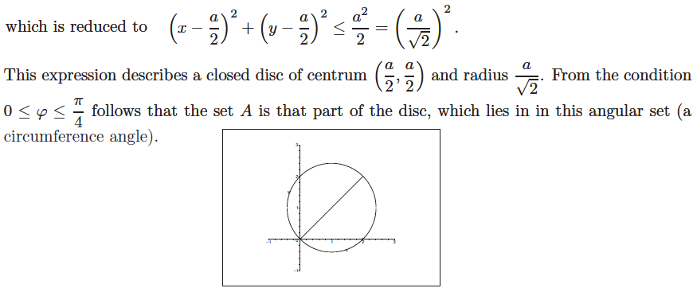

**C)** Rewrite the set $A$ using polar coordinates

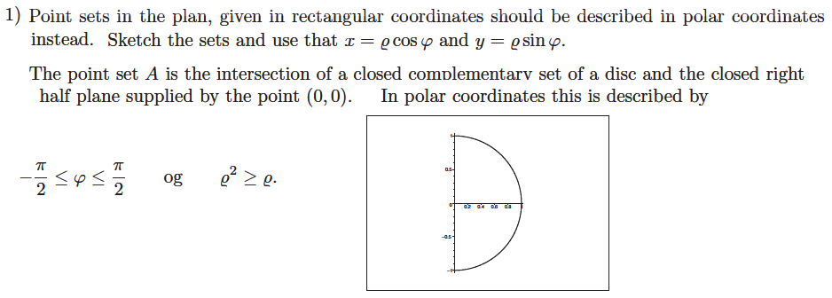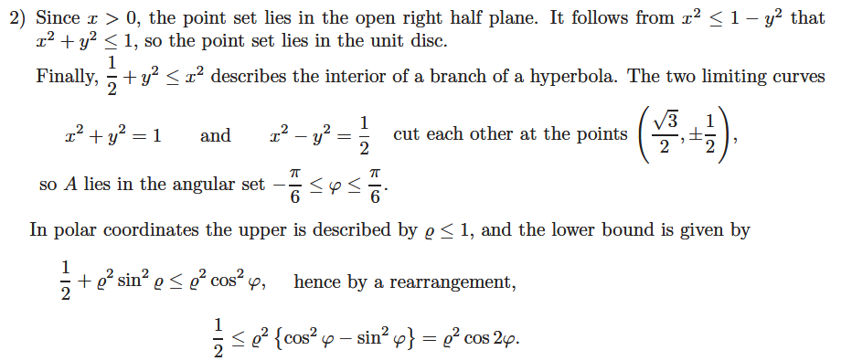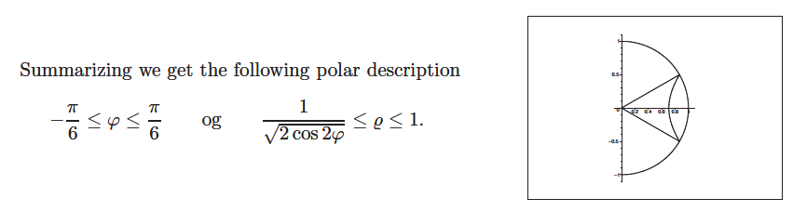

**Exercise 3.** Sketch the sets of points below and indicate which ones are convex 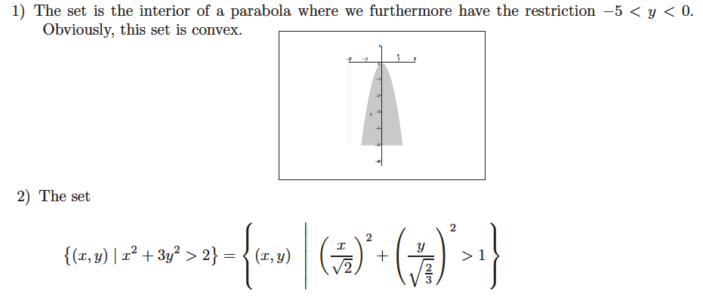

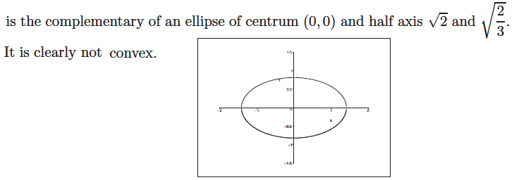

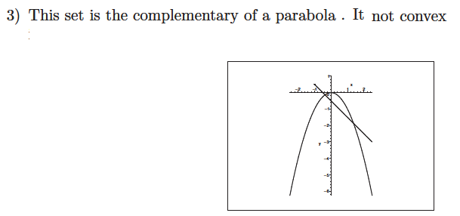

**4)** This set is the closed fourth quadrant. It is clearly convex. There is no need to sketch it