**Goal Setting**

**Goals** are well-defined plans aimed at achieving specific results. Goals are your road map to become the person you want to be and to create the life you want to live. They reflect your values and priorities about what is truly important to you.

**Time management** and **goal setting** go hand in hand. Effective time management requires effective goal setting. You can use your blocks of time more effectively when you have a clear goal of what you want to accomplish during specific times and you have ample time allocated to work on the goals. You will be rewarded with a sense of pride and accomplishment, and you will feel more in control of your time, your choices, and your personal life.

**Different Kinds of Goals**

Goals can be defined and organized in a variety of ways, such as educational goals, financial goals, or organizational goals. Another way to define goals is according to the length of time established to reach the desired outcome. Figure 4.10 shows four kinds of goals defined according to the length of time involved to achieve a specific result.

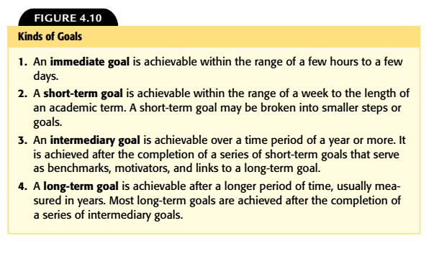

Immediate and short-term goals need not be directly linked to a long-term goal. For example, you may want to create a goal to organize an effective study area, sort your boxes of photographs, change the oil in your car, or plant a vegetable garden. You can plan, implement, and achieve immediate or short-term goals such as these within a relatively short period of time without the goals being part of a larger intermediary or long-term goal.

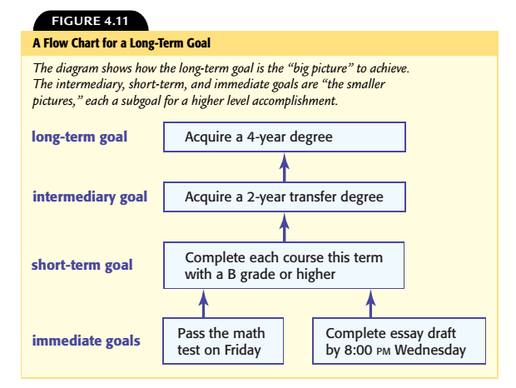

**A Four-Step Approach for Achieving Goals [STSR]:**

The Four-Step Approach for Achieving Goals is a process to set and achieve goals by using these steps: Specific, Target, Steps, and Rewards.

1. Set **S**pecific, clear, and realistic goals.  
2. Set a specific **T**arget date and time to complete each goal.  
3. Identify the individual **S**teps involved in reaching the goal.  
4. Plan a **R**eward for yourself when you reach the goal.

**Extrinsic rewards** are material things or activities that are awarded when a goal is achieved.  
**Intrinsic rewards** are emotions or feelings that a person experiences when a goal is achieved.

**A Plan of Action**

The four steps for writing and achieving goals become your *plan of action.* Creating a plan of action for any immediate goal increases the likelihood that you will achieve the goal. Each of the four steps for writing and achieving goals activates your working memory and helps you build momentum to achieve your goals:

**Step 1** helps you clarify what you wish to achieve.  
**Step 2** increases your awareness of time and activates your time management skills.  
**Step 3** motivates you to identify and organize the tasks involved.  
**Step 4** builds a motivation for you to follow through with your plan of action.

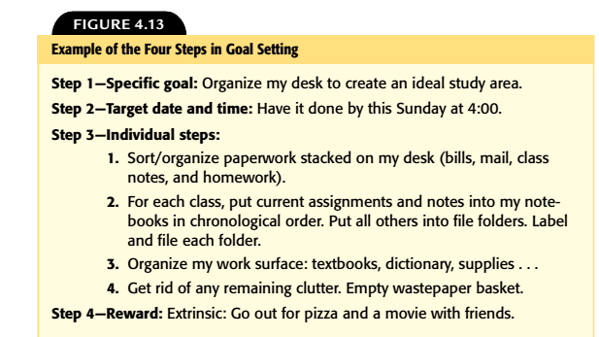

**Goal Organizers:**

A goal organizer is a chart that consists of six questions to help you plan a course of action to achieve a specific goal. Using a goal organizer helps you think seriously about the benefits, consequences, obstacles, and resources related to a specific goal.

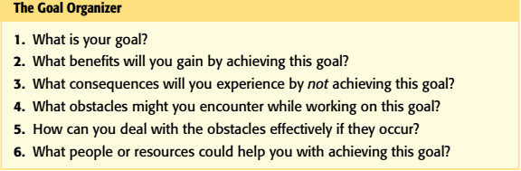

**The ABC Method:** is a goal-setting strategy to prioritize your goals according to rank of importance. Use the following steps for the ABC Method:

**1. List** all the goals you want to achieve. Limit your list to a specific time period.  
**2. Assign** a priority letter A, B, or C to the goals on your list.  
 “A” Goals: the most important to you or the ones you want or need to achieve first.  
 “B” Goals: not as high a priority as the “A” goals.  
 “C” Goals: not of such immediate importance.  
**3. Begin working** on the “A” goals. After achieving the “A” high-priority goals, move on to the “B” goals. Once those are achieved, work on achieving the lower-priority goals.