University of Guelma/ Department of English Language / 1st year Phonetics / Mrs.Boudra Amina

**LESSON 1: SYLLABLE /sɪləbəl/**

**Definition**

A syllable is a unit of pronunciation typically larger than a single sound (phoneme) and smaller than a word that can join other syllables to form longer words or a word in and of itself.

A syllable is a unit of sound which speakers use to organise sequences of sounds in their languages to create meaning in language.

A syllable is part of a word that contains sounds (phonemes). It usually has a vowel in it and may or may not have consonants before or after the vowel.

A syllable is also called a ‘beat’.

In the [International Phonetic Alphabet](https://en.wikipedia.org/wiki/International_Phonetic_Alphabet) (IPA), the period ⟨.⟩ marks syllable breaks, as in the word "astronomical" ⟨/ˌæs.trəˈnɒm.ɪk.əl/⟩.

A Greek sigma, ⟨σ⟩, is used as a wild card for 'syllable'.

**The structure of a syllable**

The general structure of a syllable (σ) consists of three segments.

* [**Onset**](https://en.wikipedia.org/wiki/Syllable#Onset)**:** is the first part that begins a syllable, it may be a [consonant](https://en.wikipedia.org/wiki/Consonant) or [consonant cluster](https://en.wikipedia.org/wiki/Consonant_cluster).
* [**Nucleus**](https://en.wikipedia.org/wiki/Syllable#Nucleus)**:** is a [vowel](https://en.wikipedia.org/wiki/Vowel) or [syllabic consonant](https://en.wikipedia.org/wiki/Syllabic_consonant), obligatory in most languages
* [**Coda**](https://en.wikipedia.org/wiki/Syllable#Coda)(literally 'tail')**:** is the final component, it is aconsonant.

The *nucleus* and the *coda* together form the syllable **rhyme** (sometimes-spelled ***rime*)**.

Theonset and nucleus group a higher-level unit, called a **"body"** or **"core"**.

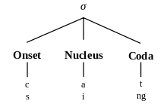

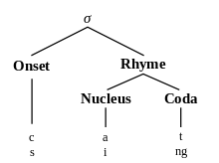

In the one-syllable English word *cat*, the nucleus is *a*, the onset *c*, the coda *t*, and the rime *at*.

This syllable can be abstracted as a *consonant-vowel-consonant* syllable, abbreviated *CVC*.

* **Syllabic consonant** is a consonant that replaces the vowel**/**ə/. It occurs in the second syllables of words like middle or midden, replacing a sequence of [schwa](https://www.thoughtco.com/schwa-vowel-sound-1691927) plus consonant..."
* **Syllabification** is the separation of a word into syllables, whether spoken or written. For exemple:Computer   has **threesyllables** (com / pu / ter)

**Types of syllable**

1. **Open Syllable vs. ClosedSyllable**

* Open Syllableend in a vowel as in try (CCV), after (VC. CV)
* Closed Syllable ends in a consonant as in clock (CCVC), ask (VCC)

1. **Heavy syllable vs. light syllable**

* A heavy syllable is one, which ends in a long vowel or diphthong or a short vowel and one consonant or more (closed) andhas stress.
* A light syllable is one which ends in a short vowel (open)and counts rhythmically as one unit

1. **Strong vs. weak syllable**

Syllables may also bear different degrees of prominence and can therefore be described as strong (stressed) vs. weak (unstressed)

* Monosyllabic Words have only one syllable.
* Polysyllabic Wordshave more than one syllable.

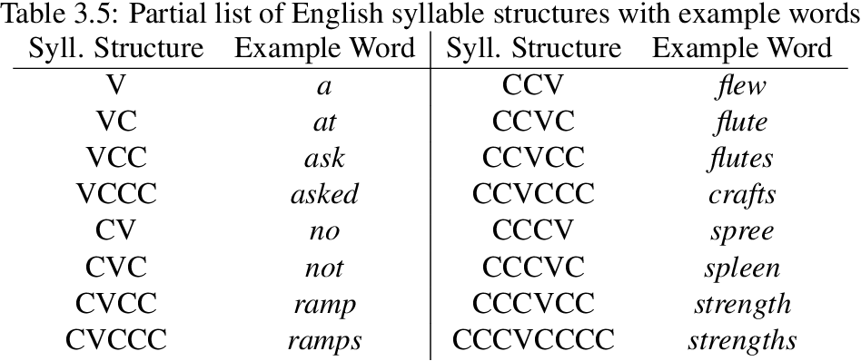

**Exercise: complete the following table**

|  |  |  |
| --- | --- | --- |
| **Word** | **Number of syllables** | **Syllable structure** |
| Phonetics |  |  |
| Phonology |  |  |
| Transcription |  |  |
| Pronunciation |  |  |
| Examination |  |  |
| English |  |  |
| Language |  |  |