**PEOPLE’ S DEMOCRATIC REPUBLIC OF ALGERIA**

**MINISTRY OF HIGHER EDUCATION AND SCIENTIFIC RESEARCH**

**UNIVERSITY OF 8 MAY 1945. GUELMA**

**FACULTY OF LETTERS AND LANGUAGES**

**DEPARTMENT OF LETTERS AND ENGLISH LANGUAGE**

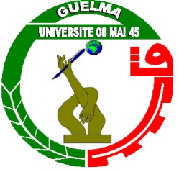

**RESEARCH PROPOSAL**

**OPTION: LINGUISTICS/LITERATURE/CIVILIZATION**

**Candidate (s)**  **Supervisor**

................................................ **Prof/ Dr/Mr/Mrs/Miss.**

**2022-2023**