**COLD CHAIN**

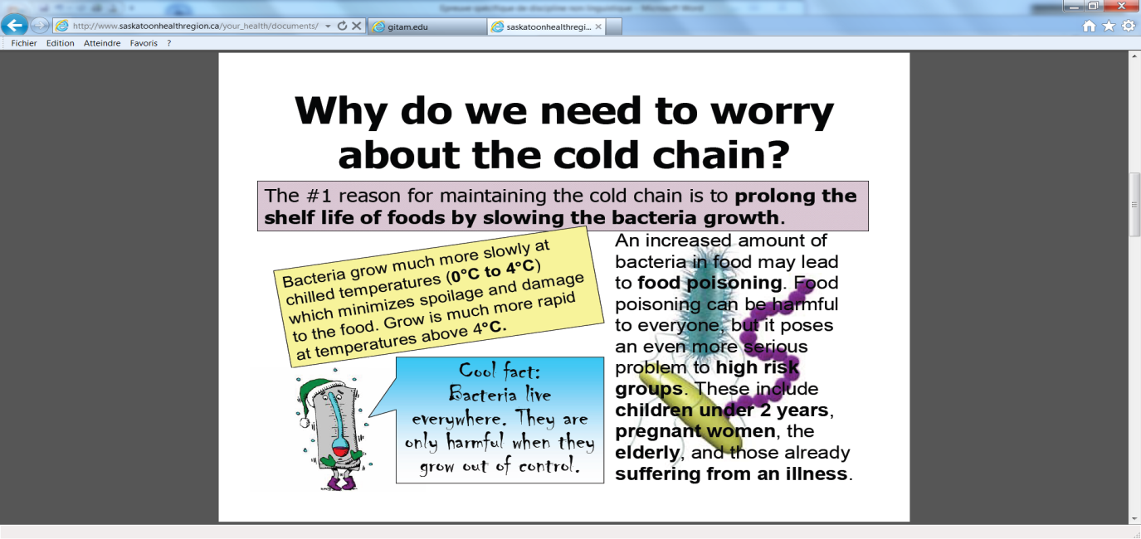

*Explanatoryleaflet for foodworkers*

|  |
| --- |
| Temperature is the most important factor that determines the rates of growth, multiplication and survival of all living organisms, such as bacteria. Growth and reproduction of living organisms are dependent on a coordinated series of enzyme-catalysed chemical reactions. The rates of enzyme reaction increase with the increase in temperature.  *From GITAM microbiology laboratory* |

Simulation of behaviour of bacteria “E.coli” in chocolate cream at 10°C (dotted line) and 15 °C (solid line):



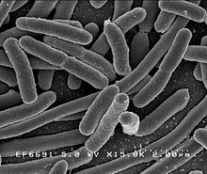

*Escherichia.coli. is a bacterium that can get into food and that can cause serious infections.*

**TASK:**

**You are a physician responsible for a food storing service in a hospital.**

**Use scientific argument to convince employees of the importance to store the food in a cold place and to maintain the cold chain.**

*You can use the documents and your knowledge to organise and support your presentation, feel free to use them in any order you like.*

Keywords you may use : kinetic factors, half-reaction time and collision theory.

|  |
| --- |
| **How Radar Guns and Radar Detectors Work**  **The basic idea behind radar is very simple: a signal is transmitted, it bounces off an object and it is later received by some type of receiver.  This is like the type of thing that happens when sound echo's off a wall. However radars don't use sound as a signal.  Instead they use certain kinds of electromagnetic waves called**[radio](http://www.ig.utexas.edu/research/projects/mars/education/radar_works.htm)**waves and microwaves.  This is where the name RADAR comes from (RAdio Detection And Ranging).  Another type of signal used that is relatively new is laser light that is used in devices called LIDAR (LIght Detection And Ranging).**  **http://www.radardetectorforum.org/wiki/images/a/a6/Radarcars.gif**  **Radio waves and microwaves are two types of electromagnetic waves.  Electromagnetic waves, which we will call EM waves, like all waves**[transport](http://www.ig.utexas.edu/research/projects/mars/education/radar_works.htm)**energy but can, do so through a vacuum.  Sound waves and ocean waves require matter to transport energy but EM waves can do so without the presence of matter.  Because of this, satellites can use radars to work on projects outside of the Earth's atmosphere and on other planets.  Another useful thing about EM waves is that they travel at a constant speed through a vacuum called the speed of light abbreviated by the letter "c" (299,792,458 meters per second).** |

**TASK :You are in a car with your young brother and you see a police car doing a speed check. Explain how RADAR works.**

*You can use the following guidelines below to organize or support your presentation; feel free to use them in any order you like.*

* + Describe how RADAR detects a car’s speed.
  + Explain why we use EM waves in space.
  + Give examples of other uses of radiowaves and microwaves

**A pH problem...**

|  |
| --- |
| **DOCUMENT 1:**    An environmental scientist has been asked to investigate the quality of water in a river where a number of dead fish have been reported. She collects a sample of water to analyze in the lab.  Her first tests suggest that the water is too acidic.  **DOCUMENT 2:**    **Effects of Low pH Levels in Water on Fish**  Very low (less than 4.5) pH values are unsuitable for most aquatic organisms. Young fish and immature stages of aquatic insects are extremely sensitive to pH levels below 5 and may die at these low pH values. Changes in pH can also affect aquatic life indirectly by altering other aspects of water chemistry. Low pH levels accelerate the release of metals from rocks or sediments in the stream. These metals can affect a fish’s metabolism and the fish’s ability to take water in through the gills, and can kill fish fry. |

**TASK:**

**You are the scientist who is in charge of analyzing the river. You have a trainee in your lab. He needs your explanations about how you will conduct experiments to analyze this water.**

*You can use the topics below to organise and support your presentation, but feel free to use them in any order you like.*

* What does pH mean? How is it possible to measure it?
* What is an acid? What is a base?
* How can we get an unknown concentration of an acid species?

**Reaction Rates.**

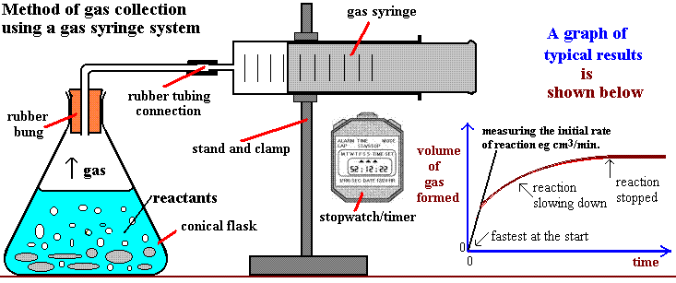

Equation : Mg(s) + 2H+(aq) 🡪 Mg2+(aq) + H2(g)

**Task**: **Use the documents above to describe the kinetic factors affecting the rate of a reaction.**

*You can use the guidelines below to organize or support your presentation, but feel free to use them in any order you like.*

* What are the kinetic factors described in the video? Do you know of any other factors?
* You have to investigate the influence of one kinetic factor on the rate of the reaction between hydrochloric acid and zinc. Explain how you would perform the experiment and the results you would obtain.
* Why is it important to be able to control the rate of a reaction?

|  |
| --- |
| **WiFi Radiation - Is WiFi Technology Bad For Your Health?** |

*The technological benefits of Wireless Fidelity technology versus the wireless hazards is a hot debate in many different countries. In the United States, a class action lawsuit has been brought against a school board who uses the technology in their classrooms. In Britain, it has been removed from some classrooms.*

|  |  |
| --- | --- |
| wifi-danger.gif | **WiFi is the wireless technology most commonly used to connect people to the internet at home, in schools, hotels...**  A wireless network uses radio waves at a frequency level of 2.4 GHz similar to micro waves and send communications across a two-way network : from the wireless router to your laptop and in the reverse way.  Wi-Fi is certainly convenient, but is it dangerous? Many believe that the low-level electromagnetic waves that radiate from the wireless internet source to each individual user can be harmful to your health, even causing cellular changes and possibly cancer. |
| Officially, the levels of **WiFi electromagnetic radiation** emitted into the environment in a hotspot * are well below recommended levels and there is no evidence of any risk to humans.  Dr. Michael Clark of the [HPA](http://www.hpa.org.uk/default.htm) (a UK health agency similar to the American [CDC](http://www.cdc.gov/)**) said, “*When we have conducted measurements in schools, typical exposures from Wi-Fi are around 20 millionths of the international guideline levels of exposure to radiation. As a comparison, a child on a mobile phone receives up to 50 percent of guideline levels. So, a year sitting in a classroom near a wireless network is roughly equivalent to 20 minutes on a mobile. If Wi-Fi should be taken out of schools, then the mobile phone network should be shut down, too — and FM radio and TV, as the strength of their signals is similar to that from Wi-Fi in classrooms.*” | |

*(The area covered by a Wi-Fi internet connection is called a hotspot)  
** CDC : center for disease control and prevention

***TASK :use the text to explain how a Wifi works, and the danger you could incur by using it. You can use the guideline below to organize your presentation but feel free to use them in any order you like.***

* A micro wave is an electromagnetic wave; explain what it means and the difference with a mechanical wave.
* Use the documents to explain the feature of a wave.
* Explain how the micro waves can be used in a micro wave oven to increase the temperature of the food.
* Some scientists investigate the potential dangers of an exposure to some electromagnetic waves. Have you ever heard about it?