**الجمـــهورية الجزائريــة الديمقراطيــة الشعبيـــة**

**REPUBLIQUE ALGERIENNE DEMOCRATIQUE ET POPULAIRE**

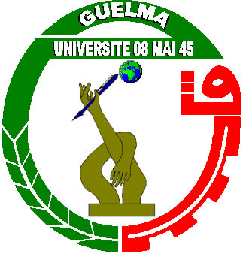

|  |  |  |
| --- | --- | --- |
| **وزارة التـعليم العــالي والبـحث العـلمي** **جـــــامعة 8 ماي 1945 - قالمة** |  | MINISTERE DE L'ENSEIGNEMENT SUPERIEUR  ET DE LA RECHERCHE SCIENTIFIQUE  **UNIVERSITE 8 MAI 1945 / GUELMA** |
| كلية الآداب واللغاتقسم الآداب و اللغة الإنجليزية | | **FACULTE DES LETTRES & DES LANGUES**  **DEPARTEMENT DES LETTRES ET DE**  **LA LANGUE ANGLAISE** |

**Course Syllabus**

Course Name: Literature

Level: Third year

Group: All groups

Year: 2023/2024

**Contact Information:**

Teacher: Dr. Nadjiba BOUALLEGUE

Email: [nadjiba.bouallegue@gmail.com /](mailto:nadjiba.bouallegue@gmail.com%20%20%20/) [bouallegue.nadjiba@univ-guelma.dz](mailto:bouallegue.nadjiba@univ-guelma.dz)

**Course Description:**

Third year literature is a very interesting and engaging course since it encompasses different ideas that make literature world attainable to students. The course is divided into two semesters: African literature and literary criticism. In African literature, students are introduced to the writing of important Anglophone African writers. They probe into the different genres and themes of African literature. In the second semester, students read literature through theory lens. Different literary criticism schools are introduced to students.

**Course Goals:**

African literature is an opportunity for students to learn about different genres and techniques of writing African literature and it also helps students to connect to socio-political context of literary works. In literary criticism, students explore and learn to appreciate the many intersections between literature and theory. This course aims at improving students’ ability to read critically and sharpen their critical faculties.

**Course Topics:**

**First Semester:**

Introduction to African literature

The issue of language in African literature

Fiction in African literature (the African novel part 1&2)

Poetry in African literature (the African poem part 1&2)

Drama in African literature

African women writers (TD presentations)

**Second Semester:**

Introduction to literary theory

Psychoanalytic literary theory

Feminist literary theory

Postcolonial literary theory

Eco-criticism

**Students Evaluation:**

1. **Exam Marks: (50%)**
2. **TD Marks: (50%)**

**Required Books and Materials:**

*A History of twentieth-century African literatures* by Oyekan Owomoyela.

*The Cambridge Companion to the African Novel* by F. Abiola Irele

*We Should All Be Feminists* by Chimamanda Ngozi Adichie

Decolonising the Mind The Politics of Language in African Literature by Ngugi  
wa Thiong’o

*A Reader’s Guide to Contemporary Literary Theory* by Raman Selden

*Literary Theory: The Basics* by Hans Bertens

*A History of Literary Criticism From Plato to the Present* by M. A. R. Habib

Interviews with writers and theorists : youtube.

Dr. Nadjiba BOUALLEGUE

Department of Arts and English Language

8 Mai 1945 University-Guelma, Algeria

